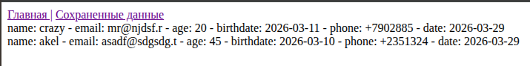
show_data.php
<?php
// $file_name = "lab1_Troshkin.txt";
// $file = fopen($file_name, "r");
$header = "Сохраненные данные";
require_once "blocks/header.php";
// $content = fread($file, filesize($file_name));
// echo "<pre>". $content . "</pre>";
// fclose($file);
$servername = "localhost";
$username = "user_veb_apache";
$password = "260019983";
$dbname = "lab2";

// Create connection
$conn = new mysqli($servername, $username, $password, $dbname);

// Check connection
if ($conn->connect_error) {
die("Connection failed: " . $conn->connect_error);
}
$sql = "SELECT * FROM lab2";
$result = $conn->query($sql);
if ($result->num_rows > 0) {
// Output data of each row
while($row = $result->fetch_assoc()) {
echo "name: " . $row["user_name"]. " - email: " . $row["email"]. " - age: " . $row["age"]. " - birthdate: ". $row['birthdate']. " - phone: ". $row['phone']. " - date: ". $row['date'] . "<br>";
}
} else {
echo "0 results";
}
?>
<script src="https://code.jquery.com/jquery-3.7.1.min.js"></script>
<!-- <script src="script.js"></script> -->
</body>
</html>

write_data.php
<?php
$host = 'localhost';
$db = 'lab2';
$user = 'user_veb_apache';
$pass = '260019983';
$charset = 'utf8mb4';

// 1. Получаем данные
$username = $_POST['name'];
$email = $_POST['email'];
$age = $_POST['age'];
$birthdate= $_POST['birthdate'];
$phone = $_POST['phone'];

// 2. Формируем дату
$current_date = date('Y-m-d');

// 3. Подключаемся
$conn = mysqli_connect($host, $user, $pass, $db);

// Проверка подключения
if (!$conn) {
die("Ошибка подключения: " . mysqli_connect_error());
}

// 4. Составляем запрос
$sql = "INSERT INTO lab2 (user_name, email, age, birthdate, phone, date)
VALUES ('$username', '$email', $age, '$birthdate', '$phone', '$current_date')";

// 5. Выполняем запрос
if ($conn->query($sql) === TRUE) {
header('Location: /show_data.php');
exit;
} else {
echo "Ошибка: " . $sql . "<br>" . $conn->error;
}

$conn->close();
?>

